Beginner Level Puzzles:
First puzzle: 'Unlock with LED'
Shows a battery, an LED, and a tray of components where the player must pick only one of each to complete the circuit and light the LED, unlocking a door.
For this level, the lock only opens when the status LED glows, so the user needs to choose the right parts to build the unlock circuit.
Components provided: battery, LED, resistors, switch, wires
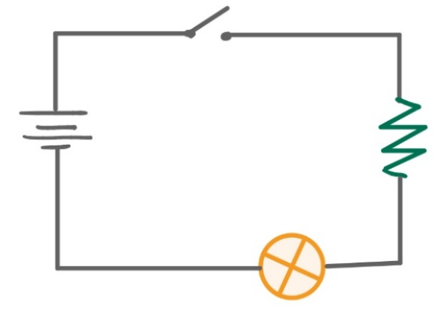
Second puzzle: 'Power Splitter'
Shows a battery connected to two bulbs in parallel with the goal of rearranging the components for brighter light.
In relation to the game, the room is too dark to find the exit, so the user needs to rewire the lamps so they shine brighter and reveal the clue of where the key to unlock the door is.
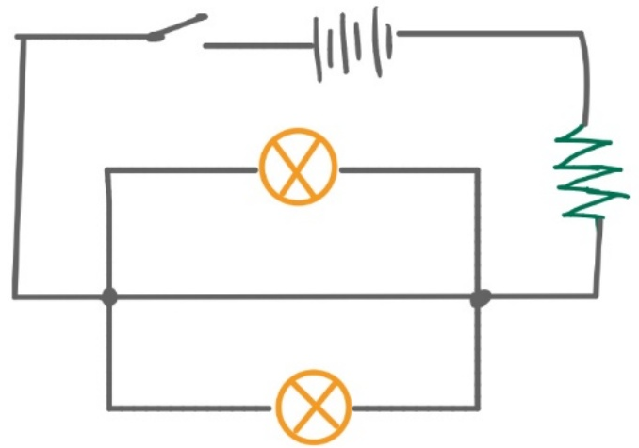
Third puzzle: 'Match the Resistance'
Shows a battery, two lamps, and a tray of resistors labeled with different values, where the player must choose the correct resistor using Ohm’s law to avoid burning the lamp. Resistors provided would be (10, 100, 220, 4.7k)ohms.
In relation to the game, the power regulator is unstable, so the user needs to find the right resistor to balance the current or risk frying the system.
